**Aayushi Dutta  
Superset ID – 6363122  
WebAPI - 2**

**1. Notice the Values controller HttpVerb action methods getting listed.**

**Click the ‘GET’ action verb method(Without the parameter).**

using Microsoft.AspNetCore.Mvc;

using System.Collections.Generic;

namespace EmployeeApiProject.Controllers

{

[ApiController]

[Route("api/[controller]")]

public class EmployeeController : ControllerBase

{

[HttpGet]

public IActionResult Get()

{

var employees = new List<string> { "Aayushi", "Abhisha", "Simran" };

return Ok(employees);

}

}

}

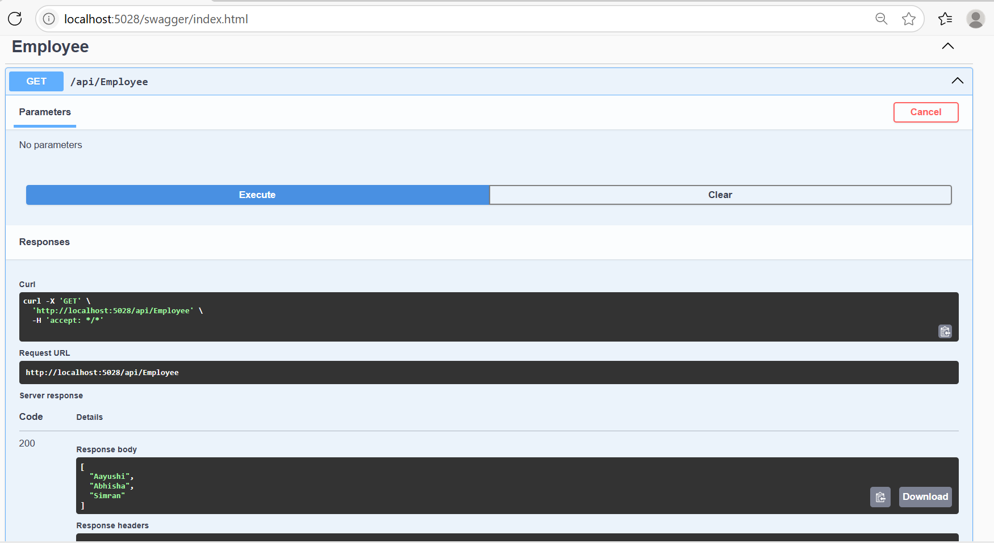

**2. Use POSTMAN tool, to point to the local Web API that was created with Employee controller. Test the GET action method using POSTMAN.**

**Verify the output if the List of employees are listed in the ‘Body’ part of the GET window on POSTMAN tool.**

**Verify the Status on the right side of the output pane on POSTMAN tool.**

using Microsoft.AspNetCore.Mvc;

using System.Collections.Generic;

namespace EmployeeApiProject.Controllers

{

[ApiController]

[Route("api/[controller]")]

public class EmployeeController : ControllerBase

{

[HttpGet]

public IActionResult Get()

{

var employees = new List<string> { "Aayushi", "Abhisha", "Simran" };

return Ok(employees);

}

}

}

**Through POSTMAN TOOL (GET)**

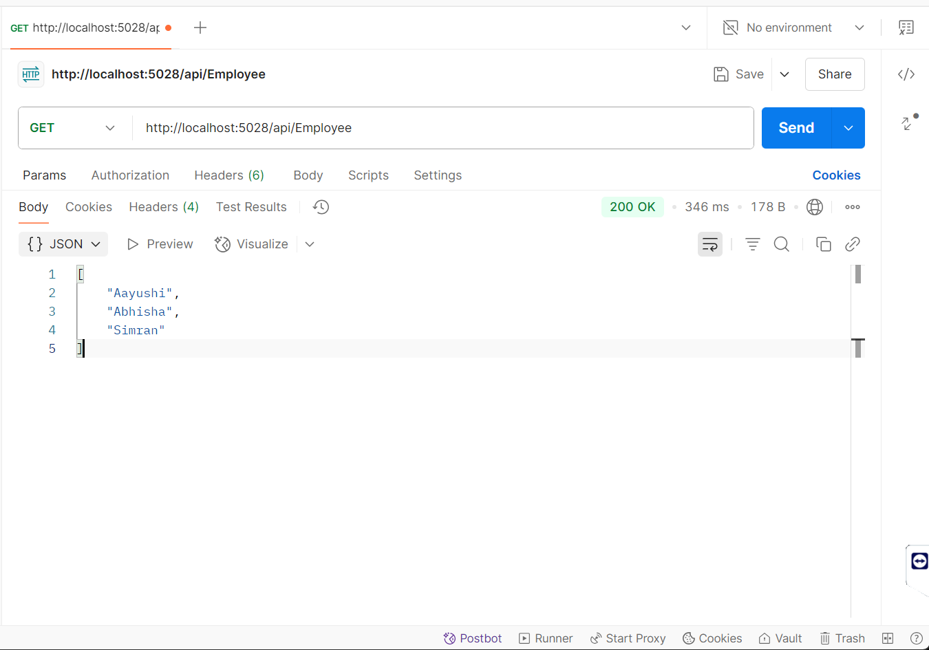

**3. Modify the Controller name in the Route attribute of the Employee controller to ‘Emp’ and check its access thru POSTMAN**

using Microsoft.AspNetCore.Mvc;

using System.Collections.Generic;

namespace EmployeeApiProject.Controllers

{

[ApiController]

[Route("api/Emp")]

public class EmployeeController : ControllerBase

{

[HttpGet]

public IActionResult Get()

{

var employees = new List<string> { "Aayushi", "Abhisha", "Simran" };

return Ok(employees);

}

}

}

**GET**

